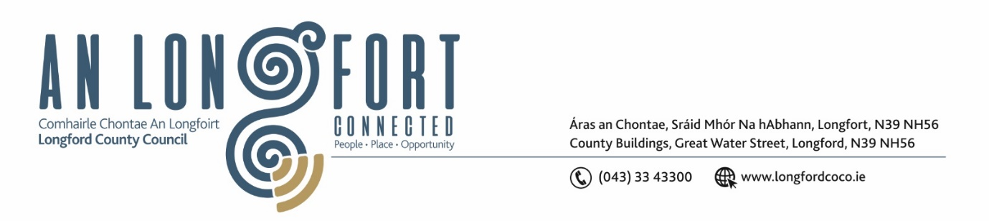

***Please note meeting will be held in the Council Chamber and via Microsoft Teams.***

1 Feabhra 2023

**Chuig: Gach Ball don Chomhairle**

A Chomhairleoir,

Iarrtar ort bheith i láthair ag Cruinniú Míosuil Chomhairle Chontae Longfoirt a tionólfar i Seomra na Comhairle, Aras an Chontae, Longford agus via MS Teams are an **Chéadaoin 8 ú Feabhra 2023 ag** **3.30pm** chun gnó a dhéanamh d’réir an Chláir thíos.

You are requested to attend the Monthly Meeting of Longford County Council to be held in the **Council Chamber and via Microsoft Teams** on **Wednesday 8 February 2023 at 3.30pm** to transact business, as set out on the Agenda hereunder.

Mise le meas,

**__________________**

***Claire McNabola***

***Meetings Administrator.***

**C L Á R**

Prayer before meeting.

Presentation by Longford County Council Vacant Homes Officer.

**1.** Confirmation of Minutes of Monthly Meeting of Longford County Council held on 18 January 2022 – copy enclosed.

**2.** Matters Arising.

**3.** Declaration of Interest by Members.

**4.** To note Management Report – to follow.

**5.** To note adopted Minutes of Corporate Policy Group Meeting held on the

13 December 2022 – enclosed.

**6. Finance and Information Technology**

1. To note adopted Minutes of meeting of Governance Strategic Policy Committee held on 18 October 2022 - enclosed.

**7. Housing, Planning, Regeneration & Capital Projects**

1. To note Planning Applications received since last meeting of the Council.
2. To note adopted Minutes of meeting of Strategic Infrastructure Strategic Policy Committee held on 20 October 2022 – enclosed.

**8. Community, Library and Cultural Services, Corporate and Human Resources**

1. To note adopted minutes of meeting of Placemaking Strategic Policy Committee held on 17th October 2022 – enclosed.
2. Consideration of representative to the Midland Regional Drug Action Task Force Committee MRDATF to replace Councillor Colm Murray.
3. To note Ethical Framework for Local Government.
4. **Notice of Motions, submitted by Councillors, as listed hereunder**

**Councillor Garry Murtagh**

Longford County Council contact all community groups directly (previously applied) to offer assistance in the completion of the Community Support Fund and the Community Support Grant. To provide training for groups that are not IT literate in the process of online application. (3 municipal districts evening/workshop).

**9. Infrastructure, Climate Action and Innovation**

1. To note adopted Minutes of meeting of Climate Action and Planning Strategic Policy Committee held on 19 October 2022 - enclosed.

**10. Training – none.**

**11. Votes of Sympathy**